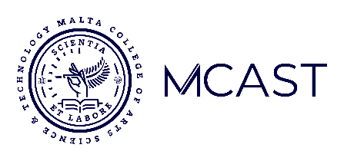
MCAST Institute for the Creative Arts
AI Use Declaration Form

This form must be completed and submitted with every assignment, as per the department's Academic Integrity and AI Policy. Transparency is essential to proving your creative ownership and learning process.
Part 1: Student & Assignment Details
Student Name: | Kimberly Parascandalo | ID Number: | 164003(L)
Unit: | PHP Database | Task: | 2
Date: | 23/01/2026

Part 2: Declaration of AI Use
Please select one of the following options:
☐ Option A: No AI Used: I declare that I did not use any generative AI tools in the conception, development, or creation of this assignment. The submitted work is entirely my own.
☒ Option B: AI Used: I declare that I did use AI tools to assist in the creation of this assignment. I have provided a transparent and accurate account of its use in Part 3 below and have submitted all required process work in support of my final submission.

Part 3: Description of How AI Was Used
(Please tick all that apply and provide a brief, specific example for each. For an explanation of each refer to the AI Use Policy Manual)
☐ Ideation & Brainstorming ☐ Research & Summarization
☐ Text Generation & Refinement (Writing/Scripting) ☐ Image/Asset Generation:
☒ Other (Please specify):
The AI helped me with complex functions and solve certain errors.

☒ I confirm that I have submitted all required process and development materials alongside my final work, as outlined in the AI Policy.
☒ I confirm that the information provided on this form is a complete and accurate representation of my use of AI tools for this assignment. I have read and understood the Academic Integrity and AI Policy, and I am aware that failing to declare AI use, or misrepresenting its use, constitutes plagiarism and will result in disciplinary action.
Print to PDF and include in your submission once completed.

